Task 2: Churn and Retention Metrics
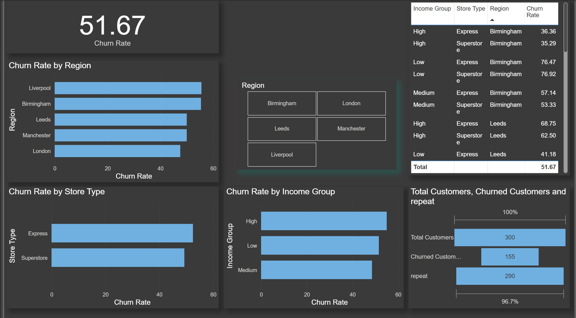

Task 3: Repeat Purchase Analysis

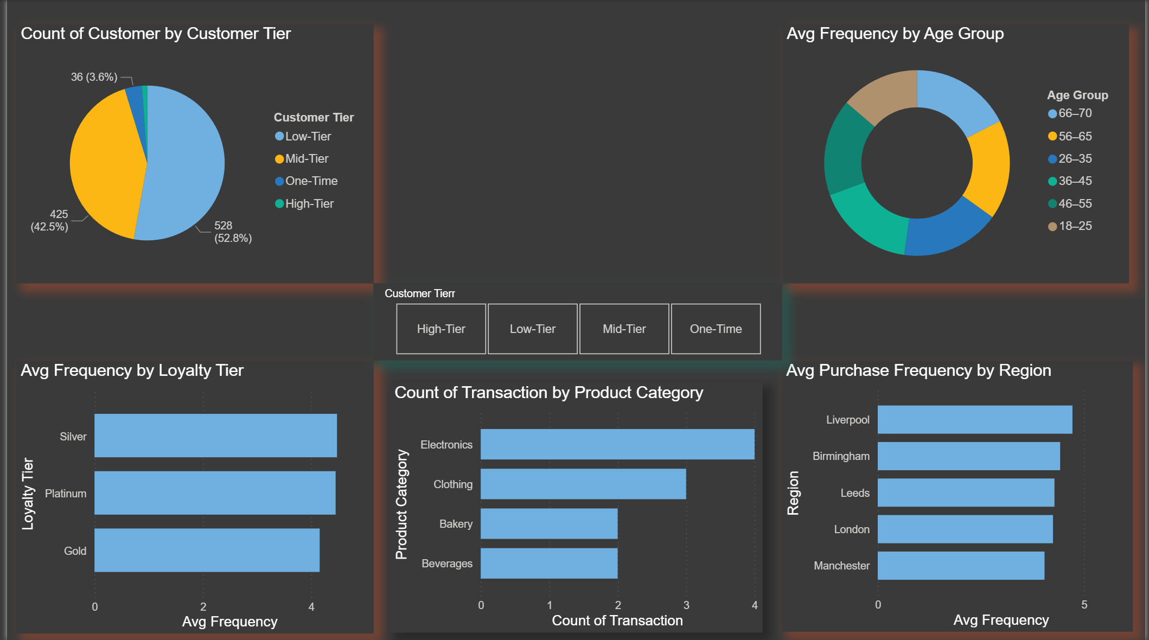

Task 4: Promotion & Loyalty Impact

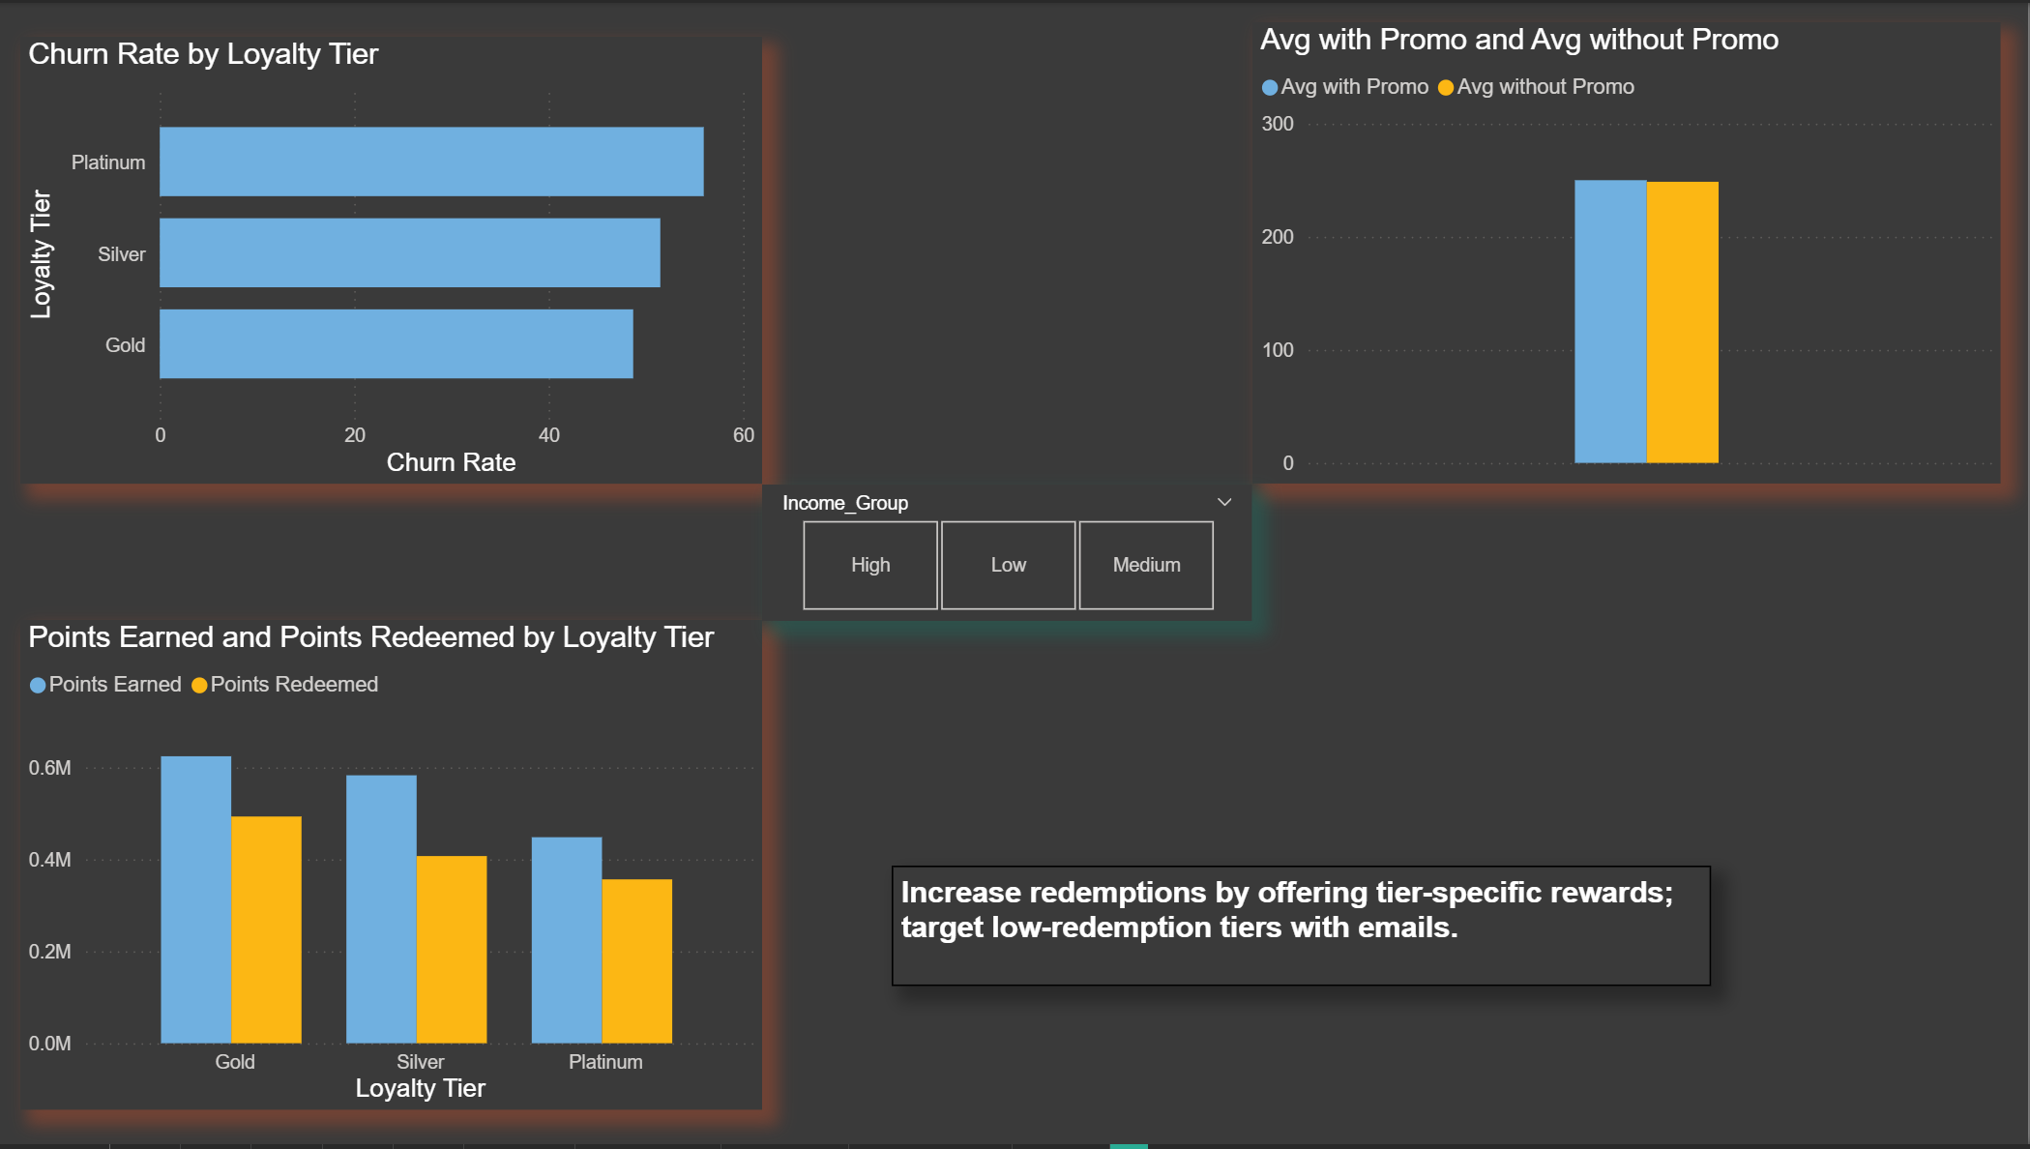

Task 5: Store Performance vs Retention

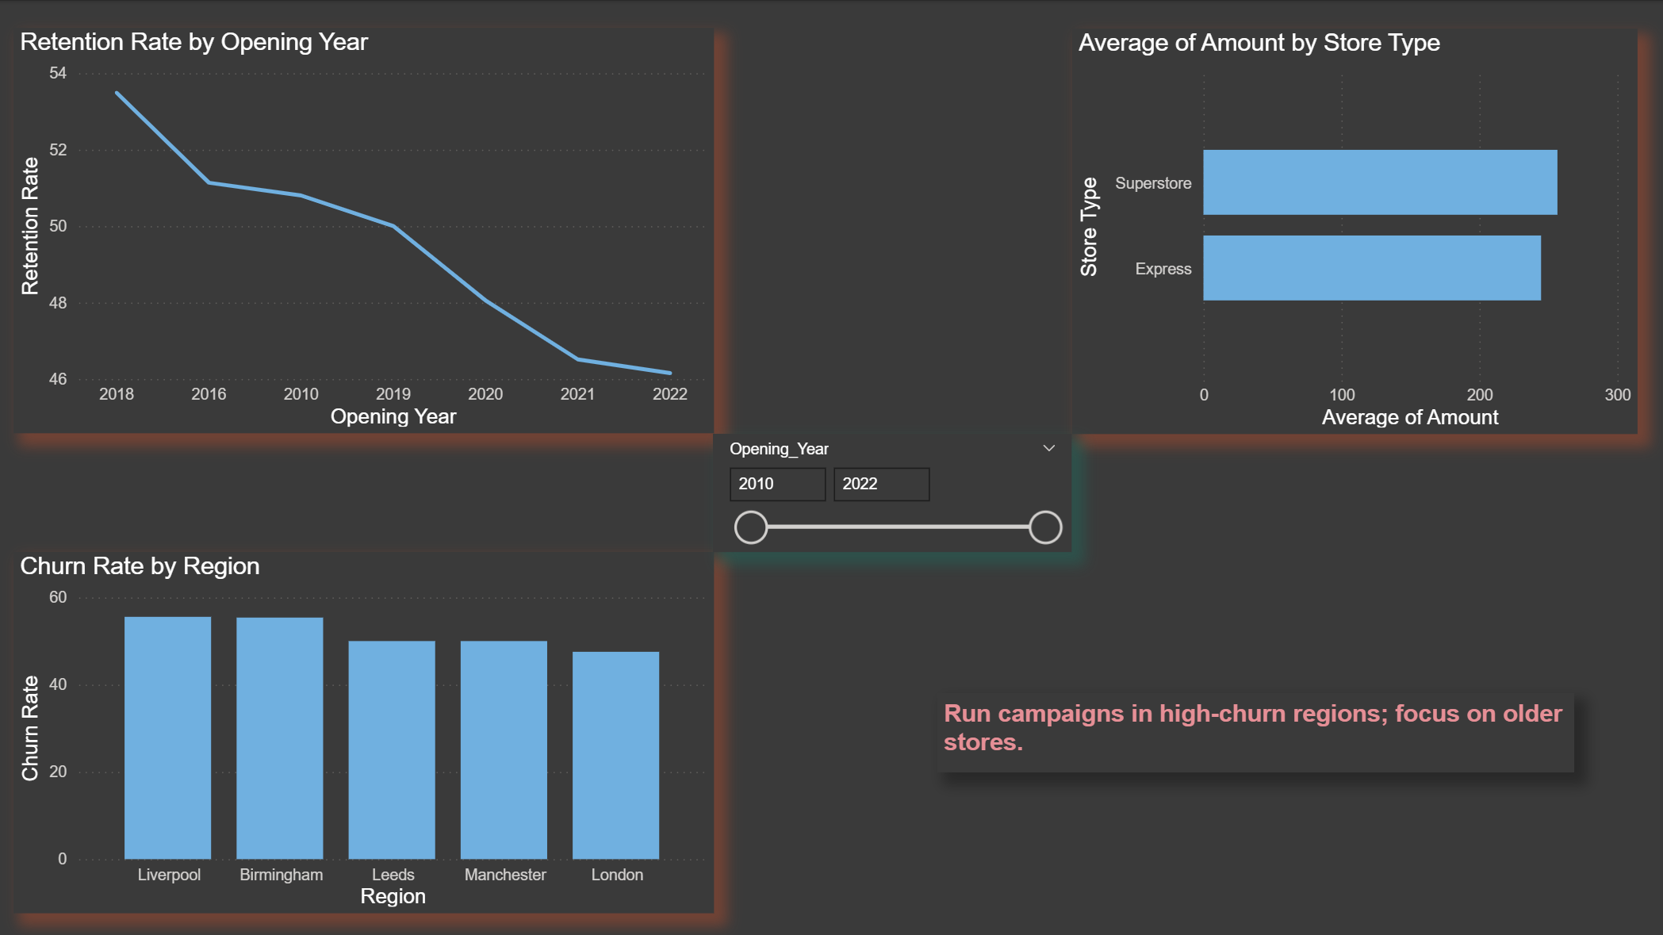

Task 6: Customer Value (CLV) Analysis

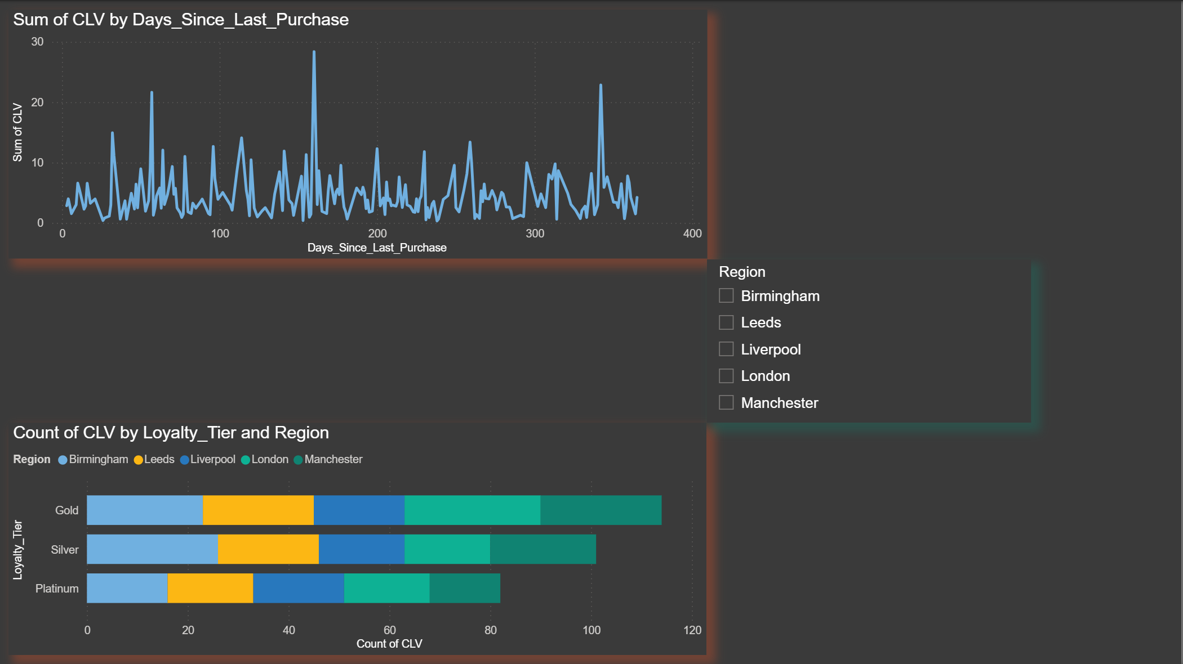

Overview KPIs

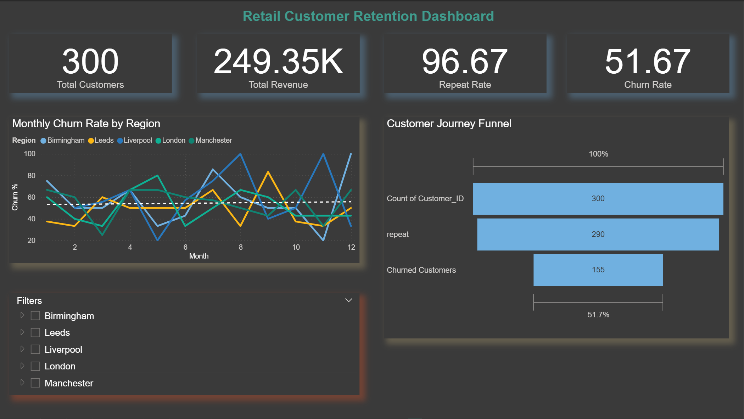

Loyalty & Promotion Impact

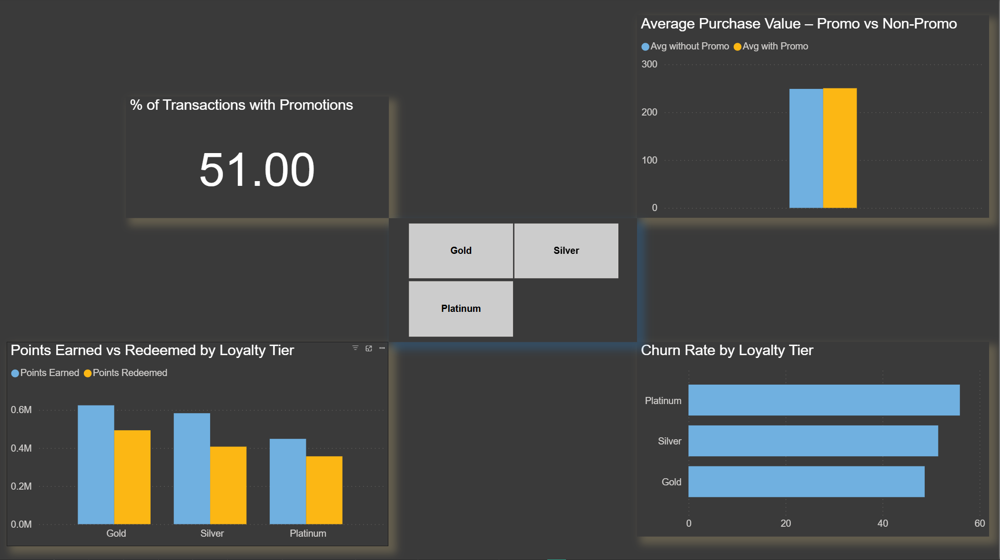

Store and Region Insights

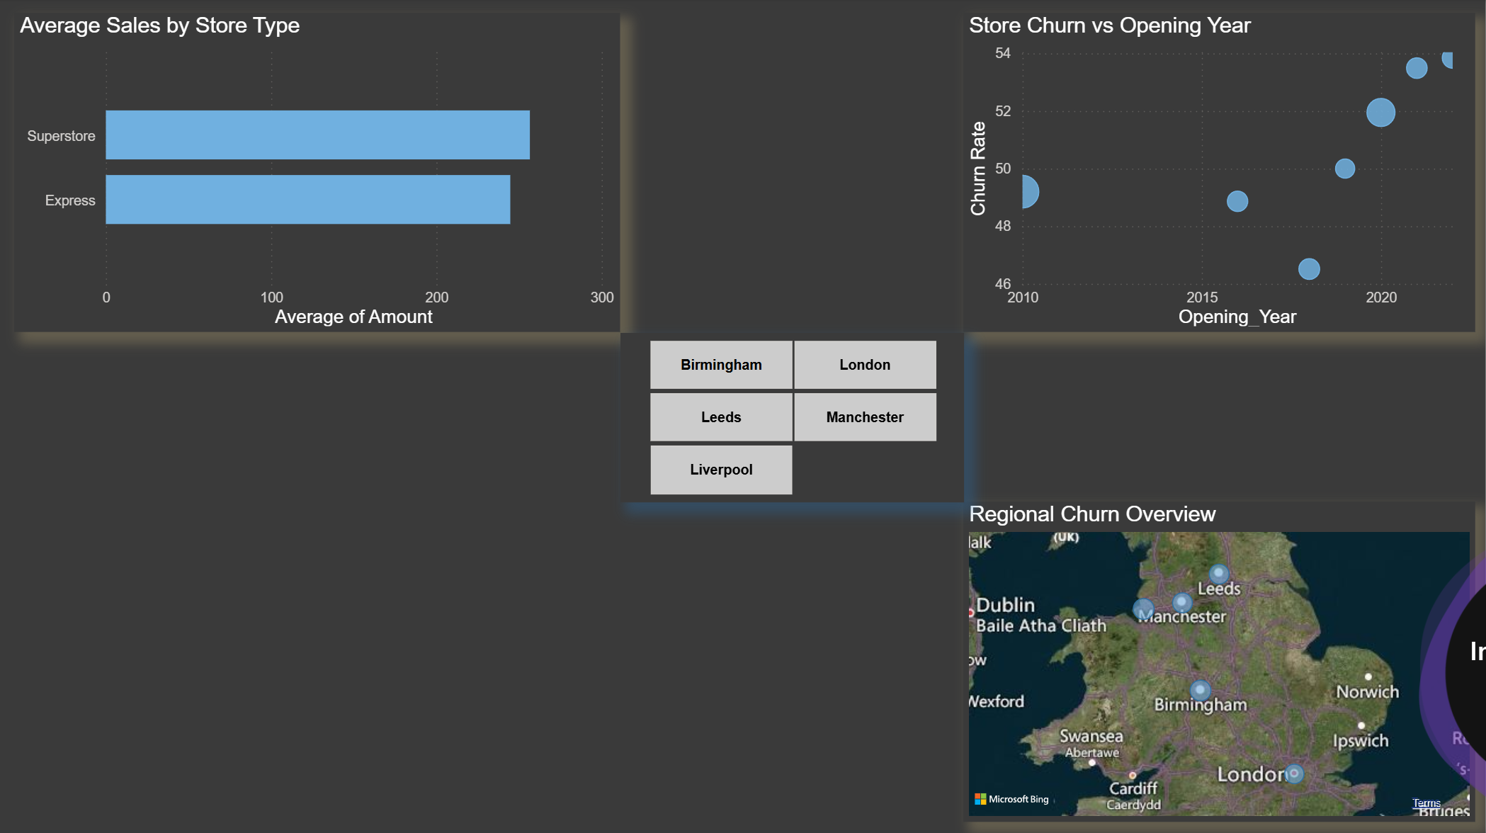

Customer Segmentation

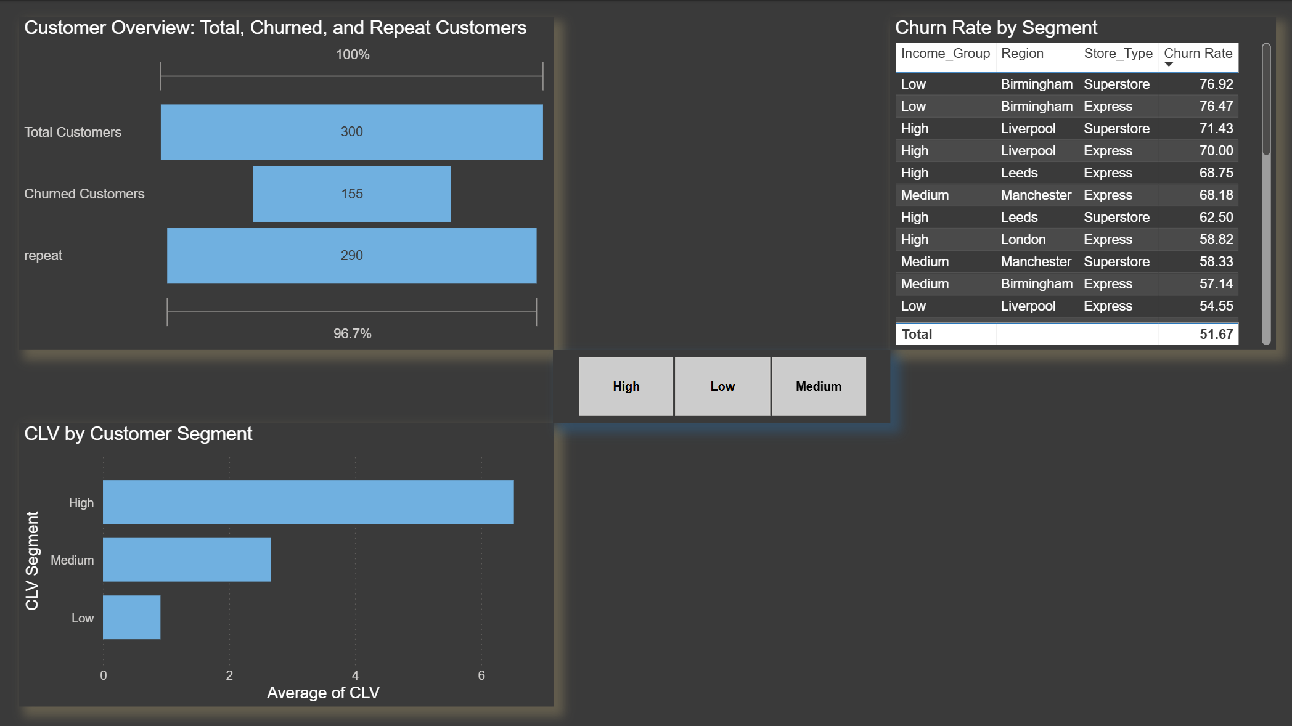

Recommendation

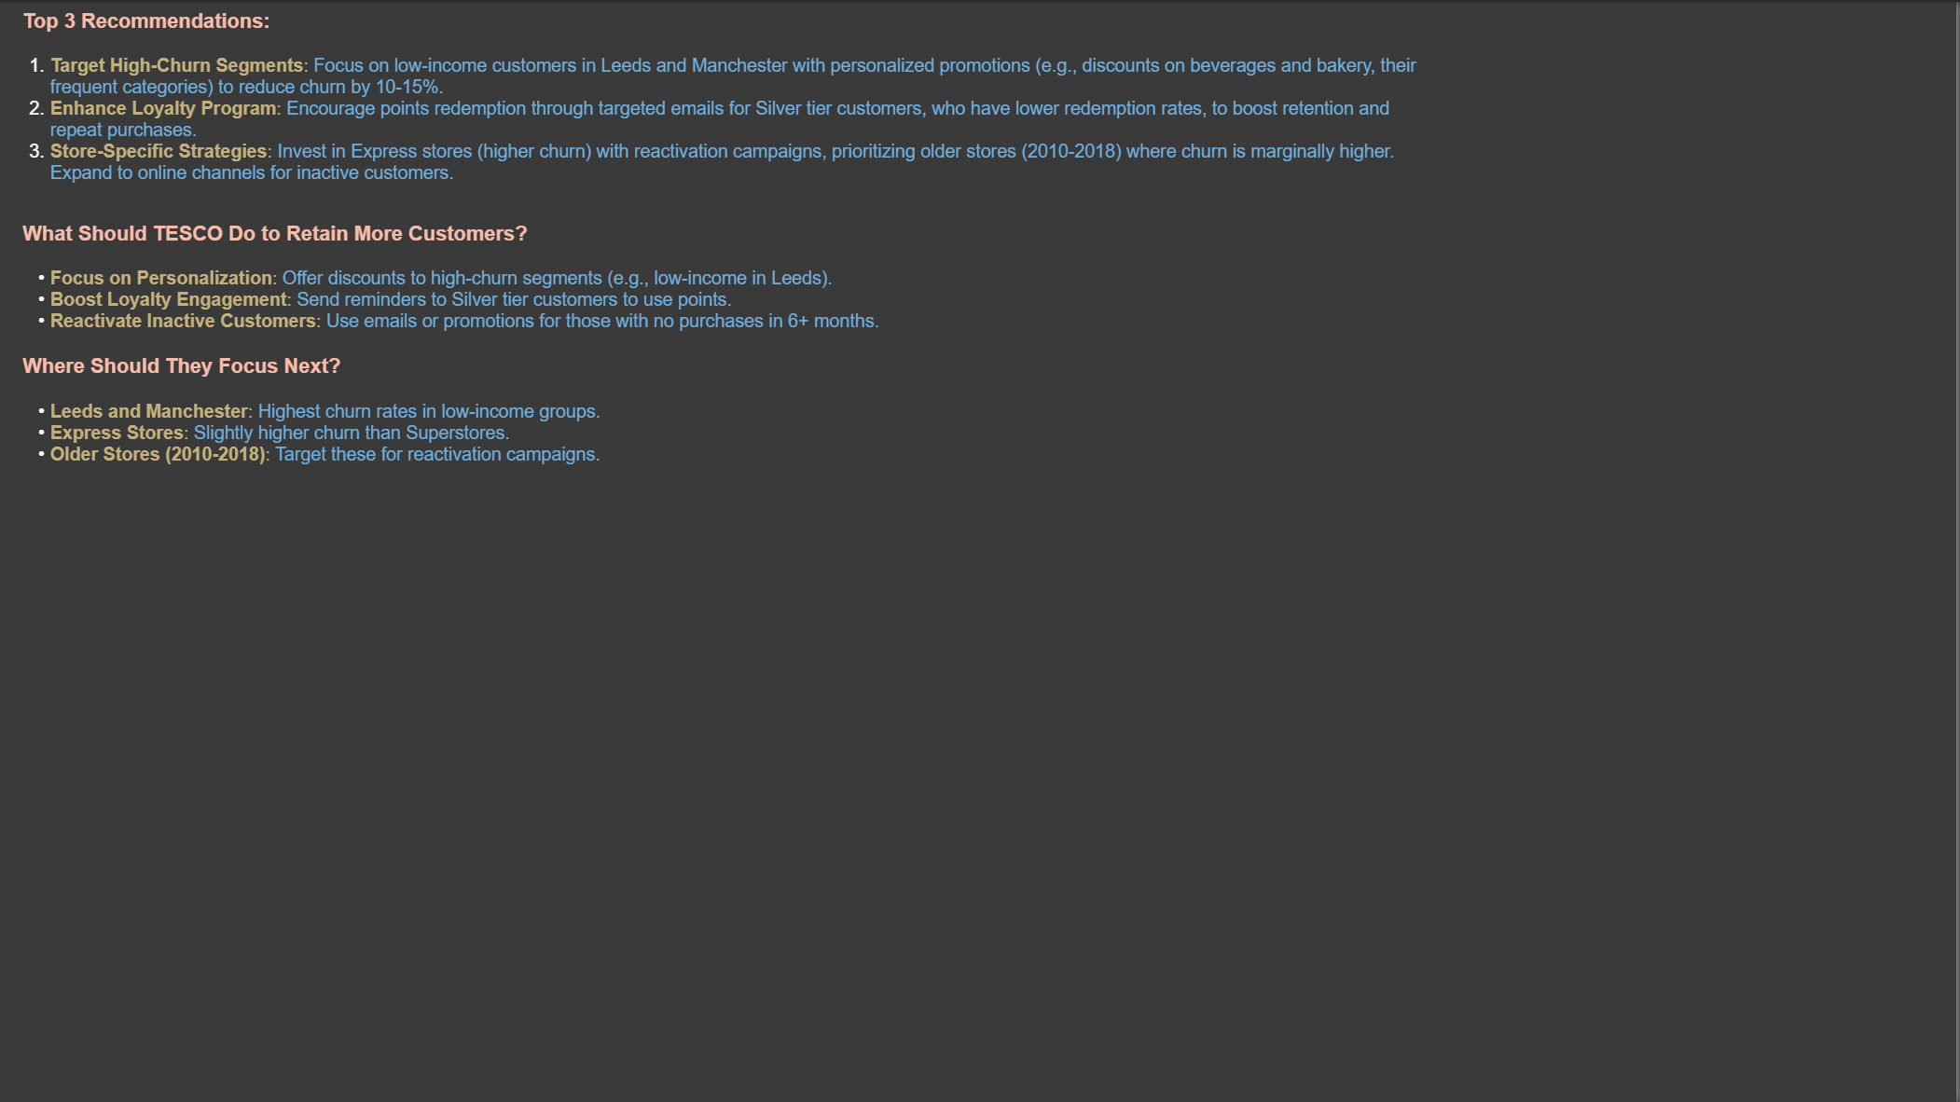

Dax Formulas:
Churn Rate = DIVIDE([Churned Customers], [Total Customers]) * 100
Churned Customers = CALCULATE(DISTINCTCOUNT(Churn[Customer_ID]), Churn[Churned] = "Yes")
repeat = CALCULATE(DISTINCTCOUNT(Transactions[Customer_ID]),FILTER(Transactions,COUNTROWS(Transactions)>=2))

repeat rate = DIVIDE([repeat], [Total Customers]) * 100

Retention Rate = (100 - (Churn[Churn Rate]))

Age_Group =
SWITCH(
TRUE(),
Demographics[Age] >= 18 && Demographics[Age] <= 25, "18–25",
Demographics[Age] >= 26 && Demographics[Age] <= 35, "26–35",
Demographics[Age] >= 36 && Demographics[Age] <= 45, "36–45",
Demographics[Age] >= 46 && Demographics[Age] <= 55, "46–55",
Demographics[Age] >= 56 && Demographics[Age] <= 65, "56–65",
Demographics[Age] >= 66 && Demographics[Age] <= 70, "66–70",
"Below 18 or Above 70"
)

CLV = DIVIDE([Total Spent], Demographics[Membership_years])/100

CLV Segment = IF([CLV] < PERCENTILE.INC(Demographics[CLV], 0.25), "Low", IF([CLV] < PERCENTILE.INC(Demographics[CLV], 0.75), "Medium", "High"))

Total Customers = DISTINCTCOUNT(Demographics[Customer_ID])

% Promo = DIVIDE(CALCULATE(COUNTROWS(Transactions), Transactions[Promotion_Applied] = "Yes"), COUNTROWS(Transactions)) * 100

Avg Frequency = AVERAGE([Purchase Frequency])

Avg with Promo = CALCULATE(AVERAGE(Transactions[Amount]), Transactions[Promotion_Applied] = "Yes")

Avg without Promo = CALCULATE(AVERAGE(Transactions[Amount]), Transactions[Promotion_Applied] = "No")

Customer Tier = SWITCH(TRUE(), [Purchase Frequency] <=1, "One-Time", [Purchase Frequency] <=4, "Low-Tier", [Purchase Frequency] <=10, "Mid-Tier", TRUE, "High-Tier")

Purchase Frequency = CALCULATE(COUNTROWS(Transactions), ALLEXCEPT(Transactions, Transactions[Customer_ID]))

Total Spent = SUM(Transactions[Amount])

